Histogram Based image segmentation

**(1) First create one denoising image :**

from skimage.restoration import denoise_nl_means,estimate_sigma

from skimage import img_as_float,img_as_ubyte,io

import numpy as np

from matplotlib import pyplot as plt

img=img_as_float(io.imread("C:\\Users\\abc\\Desktop\\image\\aeroplane\\test_image.jpg"))

sigma_est = np.mean(estimate_sigma(img,multichannel=True))

denoise = denoise_nl_means(img,h=1.15 * sigma_est,fast_mode = True,patch_size=5,patch_distance=3,multichannel= True)

denoise_ubyte = img_as_ubyte(denoise)

plt.imshow(denoise_ubyte,cmap='gray')

**→ Output :**

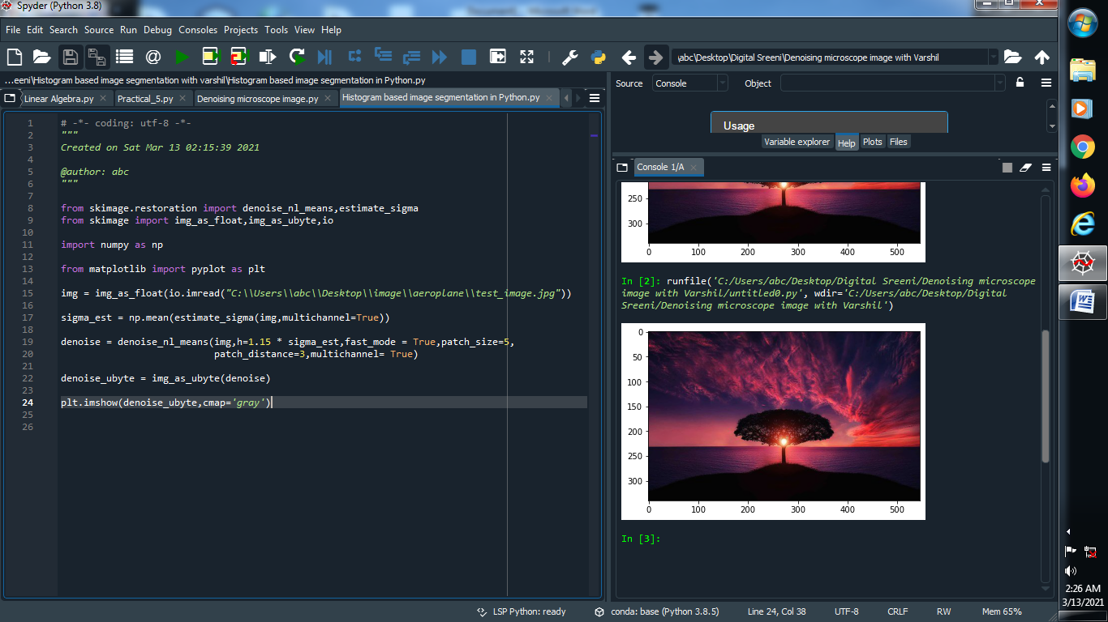

**(2) Histogram introduce on image :**

from skimage.restoration import denoise_nl_means,estimate_sigma

from skimage import img_as_float,img_as_ubyte,io

import numpy as np

from matplotlib import pyplot as plt

img=img_as_float(io.imread("C:\\Users\\abc\\Desktop\\image\\aeroplane\\test_image.jpg"))

sigma_est = np.mean(estimate_sigma(img,multichannel=True))

denoise = denoise_nl_means(img,h=1.15 * sigma_est,fast_mode = True,patch_size=5,patch_distance=3,multichannel= True)

denoise_ubyte = img_as_ubyte(denoise)

**plt.hist(denoise_ubyte.flat, bins=100,range=(0,100))**

**→ Output :**

**(Range : 0-255) (Range : 0-100)**

